There are hundreds of different sports across the globe, and many vie and jostle for a place on the Olympic and Paralympic roster. Only a few key sports display the kind of rapid, global growth that catch people’s attention and raise the long-term potential for the sport to gain its place on the world stage – which may include Olympic and Paralympic recognition. Cheerleading is one such sport, which is currently enjoying a rapid increase in global participation, an explosion of coaching awards and newly qualified coaches, strides forward in the quality of competition and development of Governing bodies, and a clear denunciation between the dance and stunting disciplines of the sport.

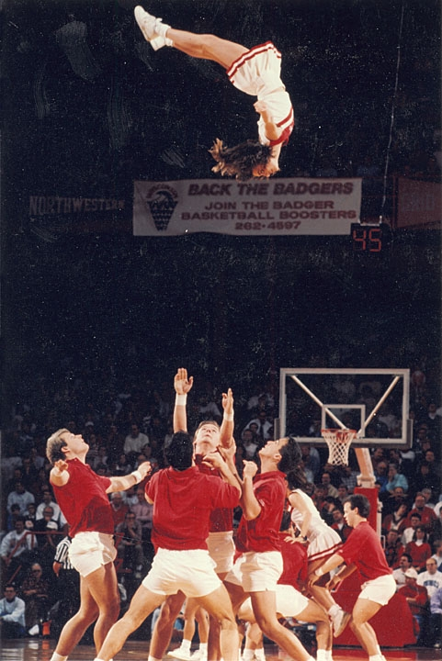
Image created by uwdigitalcollections and reproduced under a Creative Commons licence.

We listen to the student voice to understand how the sport is developing, and to gain an insight into what it feels like to be a champion cheerleader. Rebecca Small, an MSc student at the University of Hertfordshire, recounts her experiences as cheerleading rookie, champion and coach.

Please give an overview of your competitive history and coaching career, incl. qualifications
I joined university cheerleading in 2004 when I was 18 and competed for 3 years in all-girl Level 5 cheer and all-girl level 6 group stunt. I took over as Head Coach in 2007 and continued in this role until March 2010. I am USASF Level 4 qualified in stunting, tumbling and tosses. I also joined a senior team in Hertfordshire in April 2009 and continue to compete with them today.
How do you think cheerleading has impacted your life?

I think the biggest thing would be the confidence that I gained; although I'd always played team sports at a fairly competitive level, I was never really challenged physically like I was in cheerleading. We had to learn skills from scratch, and once we'd mastered things which at the beginning seemed impossible, I was able to see how far we'd come as a team in a fairly short amount of time.

Also walking into a setting with so many people who I'd never met was extremely daunting at first, but after a few weeks I realised I'd just gained a huge extended family, who would support each other and work with you, not against you; nobody was trying to be the "best" in the team because you literally can't be anything without everyone else.
Is cheerleading a big sport in the UK? Why do you think it is gaining so much popularity here?
I think compared to what UK cheerleading was when I began almost 6 years ago, the growth and development here is insane. I don't think it's a mainstream sport over in the UK yet, but over the next few years I have no doubt it will continue to grow dramatically. I think we're a long way from the standards of countries such as USA but I think it's developing at a faster pace in the UK than perhaps it is in America. I think its gaining popularity because it's a sport for everyone, you don't have to have come from a particularly athletic background, anyone can take part. Obviously you have teams which are at a higher standard, that require difficult tumbling and stunting skills - as with any other sport, you have the higher level teams, and the more recreational squads but there are opportunities available for everyone who wants to take part. It also just a really fun way to keep fit - you don't even realise how hard you're working half of the time because you're caught up in learning and perfecting skills as a team.

Is it generally only big in North America, aside from the UK or is it growing globally?
USA is definitely still the leader in terms of numbers of athletes, and provision of the sport, but certainly other Western countries such as Australia, Canada and New Zealand are continuing to develop, as are Germany and Sweden. Speaking with organisers and instructors in USA, it sounds as though South American countries (Chile, Brazil and Cuba) are starting to see huge growth and development there too, so it's definitely expanding rapidly on an international scale.
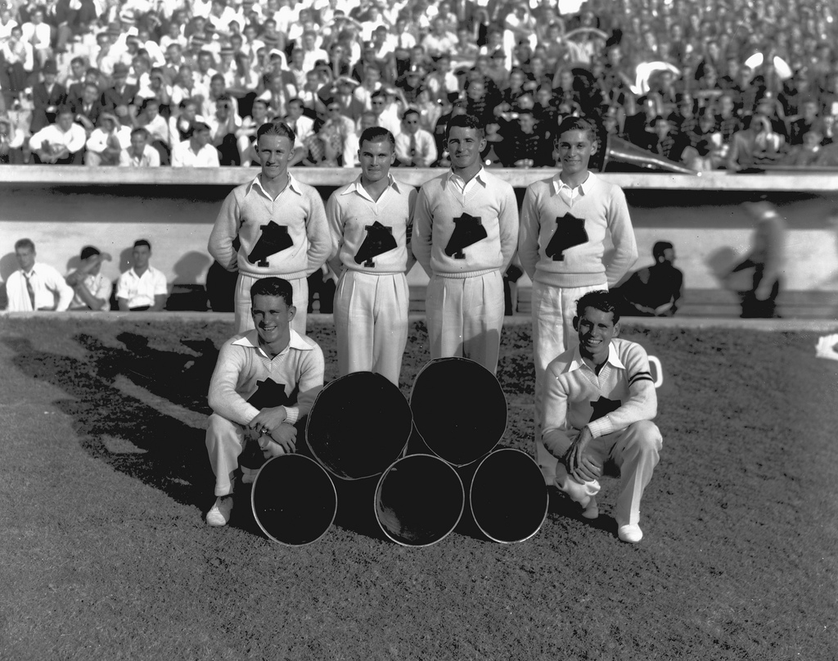
Image created by UF Digital Collections and reproduced under a Creative Commons licence.

What do you think are the benefits of cheerleading?
For younger athletes (school-aged) I think it benefits them greatly on a social level - giving them the chance to challenge themselves, make new friends, learn new skills and succeed in a way that perhaps conventional school sports don't allow. Also the sense of competition can often be a positive thing for some younger children, allowing them to push themselves to succeed. Having said that, competitiveness is generally emphasised by organisations in a fun and enjoyable way as opposed to taking on a "winning is everything" attitude. For older athletes (teenagers/university students etc) I think it can be a good outlet in many ways; it allows people to get back into sport
if you stopped playing sports after school, or to try something new that perhaps we weren't given the opportunity to experience at school. In terms of health and fitness, I think that cheerleading can be a great setting to promote exercise to the masses. Not only is the strength and conditioning aspect of cheerleading necessary for the sport, it allows people to maintain positive attitudes surrounding exercise and body awareness in general.
Do you think that it could and should be an Olympic sport, or might ever be a demonstration sport at the Olympics?
I think cheerleading could be an Olympic sport, but I don't know whether it should be at present. Obviously I would absolutely love to see cheerleading in the Olympic Games, it would be the best kind of publicity that a sport could receive, but as it stands, I'm not sure that it is developed on an international scale to the extent that enough countries would truly be able to represent cheerleading at the highest level. I also think that there needs to be more 'established' NGBs for the sport. I personally don't think that the current NGB in the UK is headed in the right direction for the development of elite cheerleading, purely because of a lack of knowledge and understanding of the entire cheerleading spectrum and sport development on the whole. Also they fail to provide sufficient coaching/judging qualification programmes and I think that that should be their primary focus in training people to instruct elite athletes. I also think many potentially elite athletes are overlooked by the NGBs because they may not be part of the well-known, established clubs, meaning that they aren't given the opportunity to excel elsewhere (i.e. on a national team).

Is it a BUCS sport and do you think it is well respected as a sport by Athletic Unions, other students, etc?
Cheerleading isn't a BUCS sport, and I think there is a lot of misconception about what cheerleading is actually about in terms of being a sport. Naturally, some universities will have new teams who are just starting out, and so people base their perceptions on seeing the mere basics of the sport - which is understandable - but there is certainly an element of ignorance surrounding the sport in HE settings. I know from a personal perspective we have fought to be respected by our AU and people just don't seem to want to know what we actually do - they're quite happy with their own perceptions.

I'd like to see cheerleading become a BUCS sport, I think it would eradicate a lot of the negative perceptions simply by being accepted by an established organisation. I don't, however, think it will happen until there is a higher awareness of the sport, and facilities are available to allow University teams to function and train appropriately and safely, and until a conventional competition setting is created for HE teams.

Is cheerleading a sport in its own right or more a support to American football?

I think that is can be classified under both settings. I absolutely think that cheerleading is a sport in its own right, and there are teams, schools and cheerleading programmes created literally to compete in the sporting side of cheerleading. Based on the athletic nature of the sport i.e. gymnastics, stunting and dance elements, I don't know how cheerleading wouldn't be classed as a sport, it's literally a combination of gym, sports acrobatics and dance. There are squads devoted solely to sideline cheering for American football, basketball, rugby etc so it would be incorrect to say that cheerleading only exists as a sport – it may just be that there is a lack of awareness for the sporting, competitive side as most people see cheerleaders at the side of a field/court.
American football is seeking Olympic recognition. Has this prompted cheerleading to also consider doing the same?
I think it was definitely prompted by the decision to seek the same for American football. Naturally, the two sports go hand-in-hand, though much of the connection between the two tends to be sideline based cheerleading, but I think if American football is successful in gaining the recognition, it will undoubtedly increase the chances of cheerleading being able to do the same.

START THE DISCUSSION
- Does your institution have a cheerleading team? If so, is it dance or stunt?
- Discuss perceptions of cheerleading amongst the class. Are they similar or different in nature to the reality?
- Why do you think stereotypification of this, or any other, sport, occurs?
- What are the effects of stereotypification on participants?

FIND OUT MORE

British Cheerleading Association
http://www.cheerleading.org.uk/

British University American Football Cheerleading (BUAF Cheer)
http://www.buafcheer.co.uk

CREDITS
© Oxford Brookes University 2010. oxb:060111:028dd

This resource was produced as part of the 2012 Learning Legacies Project managed by the HEA Hospitality, Leisure, Sport and Tourism Subject Centre at Oxford Brookes University and was released as an Open Educational Resource. The project was funded by HEFCE and part of the JISC/HE Academy UKOER programme. Except where otherwise noted above and below, this work is released under a Creative Commons Attribution only licence.

Exceptions to the Licence
The name of Oxford Brookes University and the Oxford Brookes University logo are the name and registered marks of Oxford Brookes University. To the fullest extent permitted by law Oxford Brookes University reserves all its rights in its name and marks, which may not be used except with its written permission.

The JISC logo is licensed under the terms of the Creative Commons Attribution-Non-Commercial-No Derivative Works 2.0 UK: England & Wales Licence. All reproductions must comply with the terms of that licence.

The Higher Education Academy logo and the HEA Hospitality, Leisure, Sport and Tourism Subject Centre logo are owned by the Higher Education Academy Limited and may be freely distributed and copied for educational purposes only, provided that appropriate acknowledgement is given to the Higher Education Academy as the copyright holder and original publisher.



Reusing this work
To refer to or reuse parts of this work please include the copyright notice above including the serial number. The only exception is if you intend to only reuse a part of the work with its own specific copyright notice, in which case cite that.

If you create a new piece of work based on the original (at least in part), it will help other users to find your work if you modify and reuse this serial number. When you reuse this work, edit the serial number by choosing 3 letters to start (your initials or institutional code are good examples), change the date section (between the colons) to your creation date in ddmmyy format and retain the last 5 digits from the original serial number. Make the new serial number your copyright declaration or add it to an existing one, e.g. ‘abc:101011:028dd’.

If you create a new piece of work or do not wish to link a new work with any existing materials contained within, a new code should be created. Choose your own 3-letter code, add the creation date and search as below on Google with a plus sign at the start, e.g. ‘+tom:030504’. If nothing comes back citing this code then add a new 5-letter code of your choice to the end, e.g.; ‘:01lex’, and do a final search for the whole code. If the search returns a positive result, make up a new 5-letter code and try again. Add the new code your copyright declaration or add it to an existing one.

